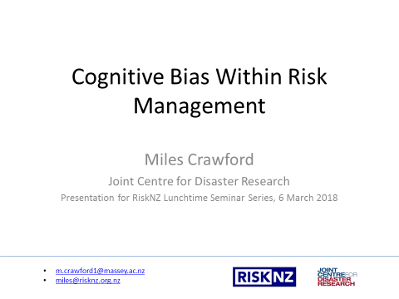

Good afternoon everybody, thank you very much for coming to listen to me.

Today’s talk is about cognitive bias within risk management, however this talk fits into a wider context for understanding risk, which is about risk perception.

Risk is a social construct. The concept of risk would not exist if people weren’t around to experience hazards, and if we didn’t come up with different options for trying to manage the impact of those hazards.

As a concept that lives in our minds, a certain risk can be perceived differently depending on who is perceiving it. How a person perceives risk is framed by things like religion, culture, gender, age, experience and knowledge.

Today’s talk fits within that broad subject of risk perception… looking at how decision-maker risk perception is affected by cognitive biases.

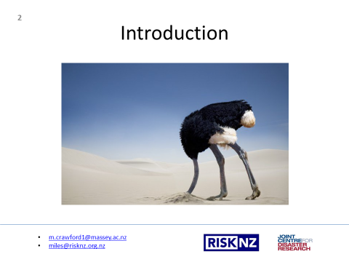

To introduce the topic today, I’m going to read out a story about how people have made bad decisions when faced with risk and uncertainty. How we might ‘stick our heads in the sand’, rather than proactively manage risky situations.

This is an excerpt from “the Ostrich Paradox’ by Robert Myer and Howard Kunreuther –

When dawn broke on the morning of September 8, 1900, the people of Galveston had no inkling of the disaster that was about to befall them. The thickening clouds and rising surf hinted that a storm was on the way, but few were worried. The local weather bureau office, for its part, gave no reason to think otherwise; no urgent warnings were issued, no calls were made to evacuate. But by late afternoon it became clear that this was no ordinary storm. Hurricane-force winds of more than 100 miles per hour were soon raking the city, driving a massive storm surge that devoured almost everything in its path. Many tried to flee, but it was too late. By the next day, more than 8,000 people were dead, the greatest loss of life from a natural disaster in US history. Fast-forward to September 2008, when Hurricane Ike threatened the same part of the Texas coast, but this time being greeted by a well-informed populace. Ike had been under constant surveillance by satellites, aircraft reconnaissance, and land-based radar for more than a week, with the news media blasting a nonstop cacophony of reports and warnings, urging those in coastal areas to leave. The city of Galveston was also well prepared: A 17-foot-high seawall that had been constructed after the 1900 storm stood ready to protect the city, and government-flood insurance policies were available to residents who were at risk of property loss. Unlike in 1900, Texas residents really should have had little reason to fear. On their side was a century of advances in meteorology, engineering, and economics designed to ensure that Ike would, indeed, pass as a forgettable summer storm. But for some reason it didn’t quite work out that way. Warnings were issued, but many in low-lying coastal communities ignored them—even when told that failing to heed the warnings meant they faced certain death. Galveston’s aging seawall was breached in multiple places, damaging up to 80% of homes and businesses in the city. The resort communities to the north on the Bolivar Peninsula, which never saw the need for a seawall, fared even worse, witnessing almost complete destruction. And among the thousands of homeowners who suffered flood losses, only 39% had seen fit to purchase flood insurance. In the end, Ike caused more than $ 14 billion in property damage and 100 deaths, almost all of it needless.

So considering this story about how we, as people, make bad decisions in conditions of uncertainty and risk, it passes onto how we, as risk managers, try to understand what our drivers are, so we can be more effective when faced with conditions of uncertainty, and more effective at reducing risk.

We assess the magnitude of hazards, find their probabilities of occurrence, and quantify the severity of their consequences. When the severity of these consequences are assessed as intolerable, we communicate this with decision-makers in order for them to approve risk reduction measures. Yet, sometimes when the severity of the risk is presented to decision-makers, they do not react to the information in the expected manner. Sometimes they will ignore the information, and at other times, they will over-react to it. This is caused by cognitive bias.

This presentation looks at what cognitive bias is, how cognitive bias affects risk management, and what we can do about it.

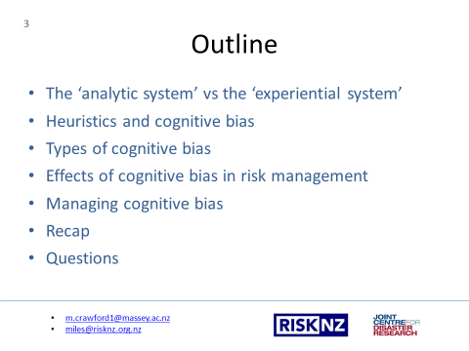

So today, I’m going to cover a few different aspects of cognitive psychology with regards to risk management:
- I’m going to explain how the analytic and experiential systems impact on how we make decisions
- I’ll give my explanation of heuristics and how they become cognitive biases
- I’ll give examples of a few cognitive biases and where they have impacted in past events.
- I’ll set out how these affect risk management decision making
and
- I’ll provide some techniques for how these biases can be managed

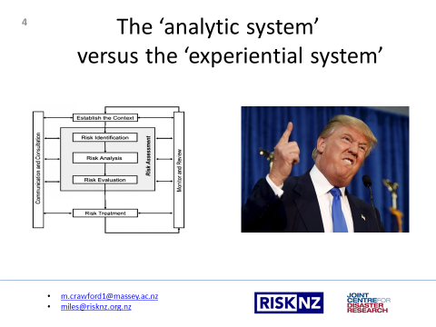

An understanding cognitive bias is important because there are two fundamental ways in which we perceive risk and make decisions. The ‘analytic system’ uses algorithms and normative rules such as probability, logic and risk assessment. It is relatively slow, effortful and requires conscious control. The ‘experiential system’ is intuitive, fast, mostly automatic, and not very accessible to conscious awareness. It relies on images, associations and emotions and is where cognitive bias resides. The ‘experiential system’ is part of what makes us human, it is a human condition that we all have.

Proponents of ‘formal’ risk management tend to view the ‘experiential system’ as irrational. Organisations don’t want to be seen as irrational so the focus for risk management is on quantifying and analysing risks. Risk management has traditionally been about probabilistic risk assessment methodologies, including: models that quantify vulnerability and exposure, risk identification techniques, cause and consequence bowtie analyses, data management, consequence matrices, vulnerability matrices, residual risk mapping, risk register and reporting systems, and a number of other analysis and reporting tools.

However, for risk management to be truly comprehensive – it requires both the analytic and experiential system working together in tandem. Risk managers and decision-makers have a pretty good understanding ‘analytic system’, but less of an understanding of the ‘experiential system’. This presentation looks at the ‘experiential system’, at our human condition, and how it impacts on risk management and decision-making.

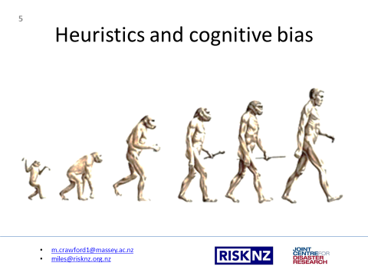

Human-beings evolved in uncertain, complex and challenging environments. In order to adapt and survive, we had to take decision-making shortcuts on our courses of action. ‘Bad’ decision-making short-cuts often meant injury or death and therefore were not made again, while ‘good’ decision-making short-cuts were repeatedly used. Over time, those good decisions became part of the make up of our human condition. Rather than being a conscious action they have become more visceral – often referred to as ‘instincts’, ‘intuition’ or ‘gut feelings’.

We refer to those gut feelings when required to quickly make decisions under conditions of uncertainty, for example, avoiding danger, or forming attachments. In most cases, these decision-making short-cuts - called heuristics - provide good approximate answers. However with our rapidly changing technological and increasing complex social environments, sometimes these heuristics, which have developed over thousands of years, are outpaced, can lose relevance, and cause us to make systematic errors. Heuristics that cause us to make systematic errors are known as cognitive biases.

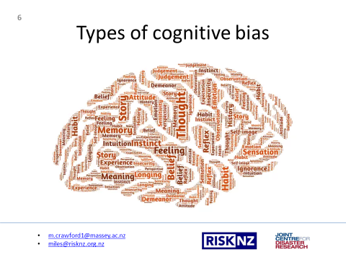

There are around 100 recognised cognitive biases that are framed by our culture, religion, environment, experiences, gender, age, etc. In general though, cognitive biases make it so that:
- We notice things already primed in memory or repeated often
- Bizarre, funny visually striking, or anthropomorphic things stick out more than non-bizarre/unfunny things
- We notice when something has changed
- We are drawn to details that confirm our own beliefs
- We notice flaws in others more easily than we notice flaws in ourselves
- We tend to find stories and patterns even when we look at sparse data
- We fill in characteristics from stereotypes, generalities, and prior histories
- We imagine things and people we’re familiar with, or fond, of as better
- We simplify probabilities and numbers to make them easier to think about
- We think we know what other people are thinking
- We project our current mind-set and assumptions onto the past and future

So today, I am going to give six examples of the more prevalent cognitive biases that impact on risk management:
- The myopia bias
- The amnesia bias
- The optimism bias
- The inertia bias
- The confirmation bias
and
- The herding bias

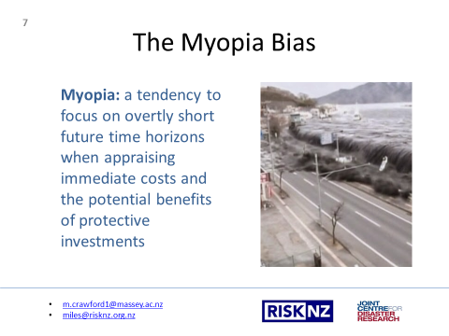

The 2011 earthquake off the Pacific coast of Tōhoku was a magnitude 9.0–9.1 undersea megathrust earthquake off the coast of Japan. It generated powerful tsunami waves that reached heights of up to 40.5 metres. When approving the sea walls that were meant to protect people and property from a tsunami, Japanese decision-makers made a fundamental error. They approved walls for a far smaller design basis earthquake than what actually occurred. Even though they had information confirming that a greater than 9 magnitude earthquake had occurred three times in the last 3000 years, and a similar event was due, they built the seawalls for a maximum magnitude of M8.2, because it was estimated to have a 99% probability of occurring within the following 30 years and was millions of dollars cheaper than building a seawall for a greater than magnitude 9 event. The money saved due to the sea wall being designed for a lesser magnitude event was dwarfed by the human and financial loss experienced as a result of the sea walls being overtopped. 16,000 people died and the cost of the disaster currently sits at $34.6 billion USD.

Along with the Myopia bias, cognitive biases in decision making that led to the sea wall being designed for a lesser magnitude event are:
- The Normalcy Bias – a tendency to underestimate both the possibility of a disaster and its possible effects.
- The Gamblers fallacy – a tendency to think that, if something happens more frequently than normal during a given period, it will happen less frequently in the future.

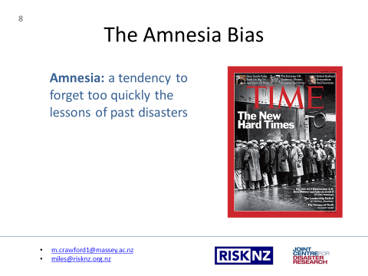

The Great Depression was a severe worldwide economic depression that took place mostly during the 1930s, originating in the United States. The timing of the Great Depression varied across nations; in most countries it started in 1929 and lasted until 1941. It was the longest, deepest, and most widespread depression of the 20th century. Yet a mere 66 years later, in 2007, it appears that the lessons of the past were not learnt… when the Global Financial Crisis impacted, presenting a number of similarities to the Great Depression, prompting it to be referred to as the ‘Great Recession’.

In that intervening 66 years, past lessons were forgotten, decision-makers kidded themselves that current safe-guards were robust even though they had never been tested, and conditions were allowed to propagate leading to the Global Financial Crisis. Along with the Amnesia bias, cognitive biases in decision making that led to the GFC are:
- The Ostrich Effect - a tendency to ignore dangerous or negative information by ignoring it or burying one's head in the sand
- Rosy retrospection - a tendency to rate past events more positively than they had actually rated them when the event occurred

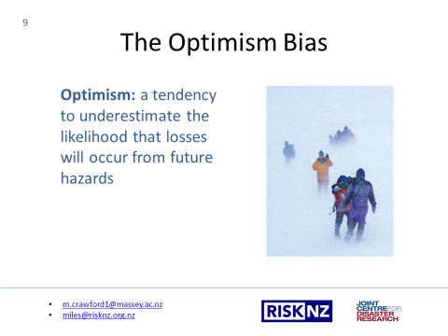

The optimism bias is most commonly associated with project management timeframes or start-up ventures. However I think this story which pulls together a few other cognitive biases in to the optimism bias is a good example:

In 1996, eight mountain climbers died on Mt. Everest when a snowstorm caught them near the summit. Accounts reviewed from the surviving climbers suggested that three cognitive biases may be partly responsible for the tragedy. The Sunk Cost Effect may have occurred when climbers insisted on continuing to the summit after expending much time and energy on the ascent. The escalated commitment to get to the top meant that insufficient resources were left for a safe descent during the storm. Second, two expedition leaders displayed Overconfidence Bias in their skills, biasing their judgments and risk assessments to bring their clients to the summit. Third, past expeditions were conducted under good weather conditions. A Recency Bias may have contributed to the leaders’ overconfidence and underestimation of the dangers from a storm. Unfortunately, the poor decisions by these two leaders led to their deaths, and the deaths of three of their team members.

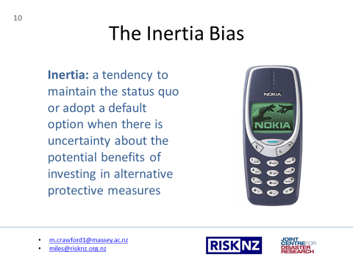

Historically, Nokia had been a surprisingly adaptive company, moving in and out of many different businesses—paper, electricity, and even gumboots. At its peak Nokia supplied 40 per cent of the world’s mobile phones and in 2008, Nokia was said to have one of the most valuable brands in the world. However, it failed to recognize that brands today aren't as resilient as they once were. By 2012 Samsung had overtaken Nokia as the world's largest manufacturer of mobile phones and by 2014 Microsoft announced that it would be dropping the Nokia brand name.

The major reasons for Nokia's decline include:
- Sticking to a legacy of hardware development when competitors where focusing on software e.g. smartphones
- A pervasive bureaucracy leading to an inability to act
- An overestimation of the strength of its brand
- Destructive internal competition

Along with the Inertia Bias, cognitive biases in decision making that led to the fall of Nokia are:
- The Ostrich effect
- The Egocentric bias - a tendency to rely too heavily on one's own perspective and/or have a higher opinion of oneself than reality
- Conservatism bias - a tendency to revise one's belief insufficiently when presented with new evidence

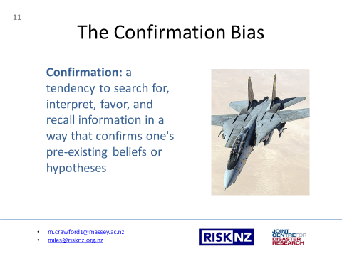

In 1998, an Iran Air civilian passenger flight was shot down by surface-to-air missiles fired from the USS Vincennes over the Persian Gulf, killing all 290 passengers on board. The commanding officer had incorrectly acted upon the belief that the Iranian Airbus was actually an F-14 fighter from the Iranian Air Force; a belief developed in the context of a high pressure situation with complicated, confusing, and contradictory information. As tragedies like this often go, there were many factors that contributed to the mistake. However, one of the main causes in to errors in decision making is Confirmation Bias, in which the context of high tensions and prior incidents in the area contributed to confirmatory thinking such that the evidence of a military aircraft was over weighted compared to the evidence of a civilian aircraft.

Along with Confirmation Bias, related cognitive biases in decision making that led to Iran Air civilian passenger flight being shot down are:
- The Anchoring Effect – the tendency to rely too heavily on the first piece of information offered (the "anchor") when making decisions
- The Simplification Bias – the tendency to selectively attend to only a subset of relevant factors to consider when making choices

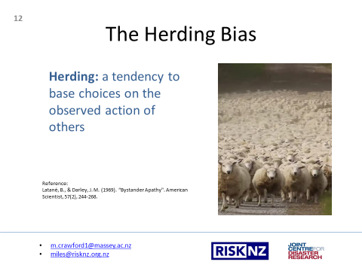

To explain this cognitive bias I am going to refer to a now-famous series of experiments by Latanée and Darley, performed in 1969, in which people acted irrationally due to the presence of others.

The first experiment put a subject alone in a room, with noticeable smoke entering from under a door. In this experiment 75% of subjects left to report the smoke. In a second experiment with three subjects, the smoke was reported only 38% of the time. In a third experiment, where there was one naive subject and two confederates who purposely ignored the smoke even when the room became hazy, only 10% of subjects left the room to report the smoke.

The smoke represents uncertainty and risk: is a fire occurring? How bad is it? Am I in danger? Yet a disconcerting number of subjects did nothing under those conditions. Rather than smoke, the uncertainty and risk could be plummeting stock value, or a string of compliance breaches with the subjects being Board Members waiting to taking their lead from other Members rather than acting themselves. Other related cognitive biases are:
The bandwagon effect – a tendency for people do something primarily because other people are doing it, regardless of their own beliefs, which they may ignore or override
The bystander effect – where individuals are less likely to offer help to a victim when other people are present.

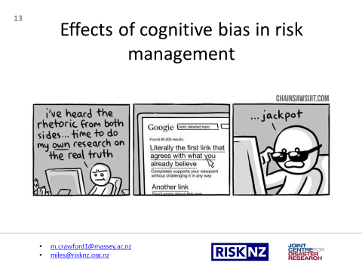

I have already given a few examples of where bad decisions are made in the face of uncertainty and risk. What people have learned from these examples, and many more, is that cognitive biases affect risk management decisions in ways where:

- We will not act unless we are confident we can make an impact
- The only way we can stay focussed is by favouring the immediate, relatable things in front of us
- We tend to keep supporting things we’ve invested time and energy in even though they aren’t producing results
- We are scared of making mistakes and therefore aim to avoid irreversible decisions
- We favour simple looking options and complete information over complex ambiguous options
- We edit and reinforce some memories to suit our purposes
- Specifics are too hard to process so we discard them to form generalities
- We miss important factors by over-simplifying scenarios into their key elements
- We store memories differently based on how they were experienced

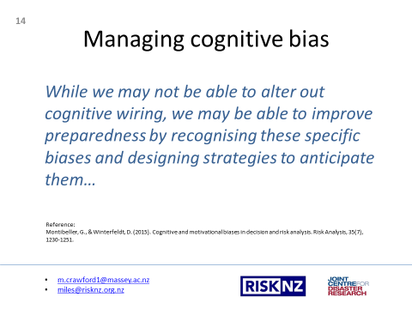

While we may not be able to alter out cognitive wiring, we may be able to improve preparedness by recognising these specific biases and designing strategies to anticipate and use them…

There is a fair amount of research on what our biases are, however there is much less research on how we can manage them. “De-biasing” people is difficult, with many cognitive biases being resistant to logic, or the use of training and tools.

The most fundamental “de-biasing” technique is awareness. If decision-makers have a better awareness of how cognitive biases influence their risk perception, then they are better equipped to catch themselves from giving an irrational response.

One way this can be achieved for a given risk context is through a ‘Behavioural Risk Audit’, where decision-makers:
- Review the main cognitive biases that underlie how they might perceive a certain risk
- Describe how each of these biases can lead their misperception of that risk
- Appraise how their misperceptions could degrade the efficacy of risk management measures
- Review a suite of “de-biasing” measures to overcome potential cognitive biases

So I have pulled together a few “de-biasing” measures relevant to the biases I have referred to today:

The Myopia Bias – explicitly encourage decision makers to think about more objectives, new outcomes, and other possible states of the future. Frame the probabilities for events so that they fit within relatable human timeframes, e.g. 10% chance of 1600 dead in 50 years, rather than 1600 dead in 500 years.

The Amnesia Bias – Avoid loaded descriptions of consequences in the attributes. Cross-check judgments with alternative elicitation techniques for value functions, weights, and probabilities. Use multiple experts with alternative points of view.

The Optimism Bias – Provide probability training. Start with extreme estimates and avoid central tendency anchors. Use counterfactuals to challenge extremes, for example “if a storm occurs on your summit bid, then you will die”. Place hypothetical bets against the desired event or consequence. Use decomposition and realistic assessment of partial probabilities.

The Inertia Bias – Use analysis with multiple stakeholders providing different value perspectives. Use multiple experts with different opinions. Use incentives and adequate levels of accountability. Use multiple elicitation procedures and cross-checks.

The Confirmation Bias – Use multiple experts with different points of view about hypotheses. Challenge probability assessments with counterfactuals. Probe for evidence for alternative hypotheses.

The Herding Bias – Prompt for alternatives and objectives. Ask for extreme or unusual scenarios. Use group elicitation techniques

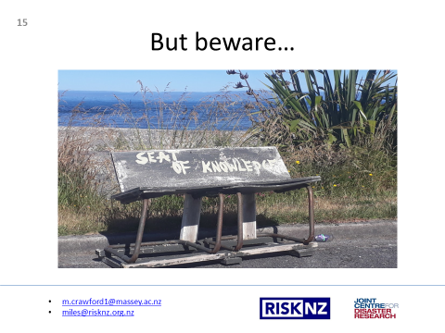

Now that we have knowledge of cognitive biases, we need to beware how that knowledge impacts on how we - as risk managers - perceive risks. - We may be sitting on a seat of knowledge which could easily collapse beneath us.

I must warn that this presentation touches upon only a small subset of biases. So in applying our understanding of cognitive bias, please recall that, unless you are a cognitive psychologist, we are only familiar with a few biases, where there is a much greater proportion of relevant biases out there, interacting in complex ways, that we are not familiar with.

We also need to be aware of your own biases. There is another cognitive bias called the ‘Blind Spot Bias’, where people recognise the impact of biases on the judgement of others, while failing to see the impact of biases on their own judgement. While us risk managers are trying to manage risk in the face of decision maker biases, we need to be cognisant of the fact that we might only provided risk management information that our own cognitive biases have deemed as valuable, relevant or actionable.

Furthermore, the more we know of cognitive bias, the less effective we may become in managing them. An awareness of cognitive biases may result in risk managers and decision makers taking a longer – while we ponder our cognitive biases – to arrive at a risk management decision that we would have arrived at anyway.

So in summary, just because we have an awareness of cognitive biases doesn’t make us experts in seeing into people’s minds and understanding what their risk management drivers and perceptions are. While an awareness of cognitive bias gives us a better understanding of how decisions-makers may react in unexpected ways to the information we provide them, it doesn’t actually mean that their unexpected reactions are wrong.

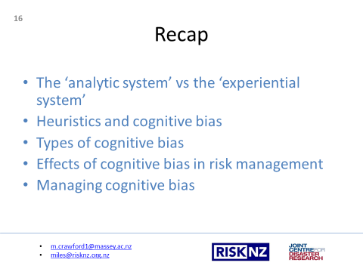

To recap:
- I have explained how we use both our ‘analytic system’ and our ‘experiential system’ in combination to make risk based decisions, but risk management tends to focus more on the ‘analytic system’, at the expense of robust decision making.
- We all use heuristics in our decision-making and most of the time that works well. Cognitive bias is where heuristics go wrong.
- We covered six prevalent cognitive biases and how they affect risk management decision making
And
- We reviewed some de-biasing measures for each of those cognitive biases.

So at the start of this talk I told a story about Galveston, hurricanes and people reacting in unexpected ways to clear and logical risk information. Situations like this will continue to happen because cognitive bias and reacting in unexpected ways to risk is a human condition. However, with an understanding of how cognitive bias influences the perception of risk, we - as risk managers – have another tool to better influence decision-makers to apply risk reduction measures so that the consequences of the next event aren’t as bad, whether it is a hurricane, a financial crisis, or a mountaineering expedition.

Thank you.

